# **Pizza Sales SQL Report**

**KPIs**

1.Total Revenue:

select sum(total_price) as Total_Revenue

from pizza_sales;



2.Average Order Value:

select sum(total_price)/count(distinct order_id) as Avg_Order_Value

from pizza_sales;



3.Total Pizzas Sold:

select sum(quantity) as Total_Pizzas_Sold

from pizza_sales;



4.Total Orders:

select count(distinct order_id) as Total_Orders

from pizza_sales;



5.Average Pizzas Per Order:

select cast(cast(sum(quantity) as decimal(10,2))/ cast(count(distinct order_id) as decimal(10,2)) as decimal(10,2)) as Avg_Pizzas_Per_Order

from pizza_sales;



**Daily Trend for Total Orders**

SELECT DAYNAME(STR_TO_DATE(order_date, '%d-%m-%Y')) AS Order_Day, COUNT(DISTINCT order_id) AS Total_Orders

FROM pizza_sales

GROUP BY Order_Day

order by Total_Orders desc;

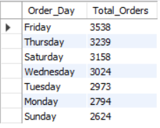

**Hourly Trend for Total Orders**

(24*-*HourTimeFormat)

Note: Here 12 means 12-13, 13 means 13-14 and so on.

select hour(order_time) as hour_time, count(distinct order_id) as Total_Orders

from pizza_sales

group by hour_time

order by Total_Orders desc;

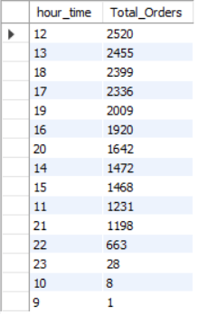

**Monthly Trend for Total Orders**

SELECT monthname(STR_TO_DATE(order_date, '%d-%m-%Y')) AS Month_Name, COUNT(DISTINCT order_id) AS Total_Orders

FROM pizza_sales

GROUP BY Month_Name

order by Total_Orders desc;

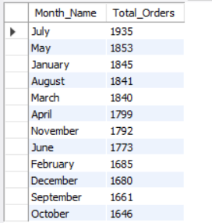

**% Of Sales by Pizza Category**

select pizza_category, ((sum(total_price))/ (select sum(total_price) from pizza_sales where month(STR_TO_DATE(order_date, '%d-%m-%Y'))=1))*100 as Percentage_Share_Total_Sales

from pizza_sales

where month(STR_TO_DATE(order_date, '%d-%m-%Y'))=1

group by pizza_category

order by Percentage_Share_Total_Sales desc;

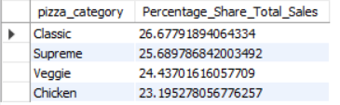

**% Of Sales by Pizza Size**

select pizza_size, cast(((sum(total_price))/ (select sum(total_price) from pizza_sales where quarter(STR_TO_DATE(order_date, '%d-%m-%Y'))=1))*100 as decimal(10,2)) as Percentage_Share_Total_Sales

from pizza_sales

where quarter(STR_TO_DATE(order_date, '%d-%m-%Y'))=1

group by pizza_size

order by Percentage_Share_Total_Sales desc;

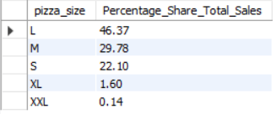

**Total Pizzas Sold by Pizza Category**

select pizza_category, sum(quantity) as No_of_pizzas_sold

from pizza_sales

group by pizza_category

order by No_of_pizzas_sold desc;

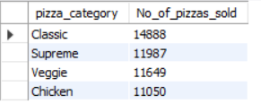

**Top 5 Pizzas by Revenue**

select pizza_name, sum(total_price) as Total_Revenue

from pizza_sales

group by pizza_name

order by Total_Revenue desc

limit 5;

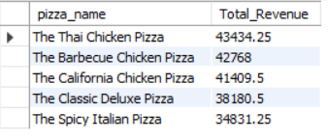

**Bottom 5 Pizzas by Revenue**

select pizza_name, sum(total_price) as Total_Revenue

from pizza_sales

group by pizza_name

order by Total_Revenue asc

limit 5;

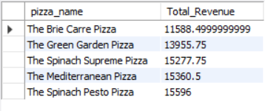

**Top 5 Pizzas by Quantity**

select pizza_name, sum(quantity) as Total_Quantity

from pizza_sales

group by pizza_name

order by Total_Quantity desc

limit 5;

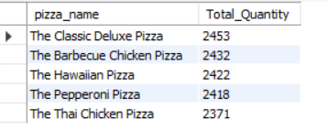

**Bottom 5 Pizzas by Quantity**

select pizza_name, sum(quantity) as Total_Quantity

from pizza_sales

where month(str_to_date(order_date, '%d-%m-%Y'))=8

group by pizza_name

order by Total_Quantity asc

limit 5;

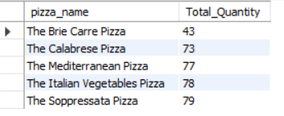

**Top 5 Pizzas by Total Orders**

select pizza_name, count(distinct order_id) as Total_Orders

from pizza_sales

group by pizza_name

order by Total_Orders desc

limit 5;

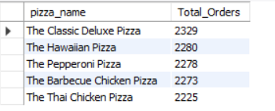

**Bottom 5 Pizzas by Total Orders**

select pizza_name, count(distinct order_id) as Total_Orders

from pizza_sales

group by pizza_name

order by Total_Orders asc

limit 5;

